Design Your Project – Best Practices

1. Clean and Simple Navigation
- Ensure the navigation is intuitive and easy to understand
- Use clear and descriptive labels for the menus
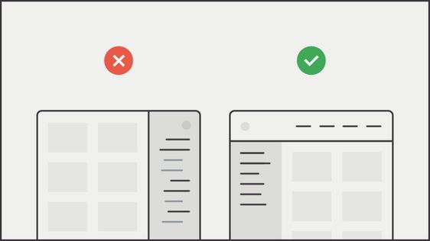

2. Consistency
- Apply a consistent design across all pages and interface elements
- This includes colors, fonts, buttons, and icons
- Consistency helps users navigate more easily
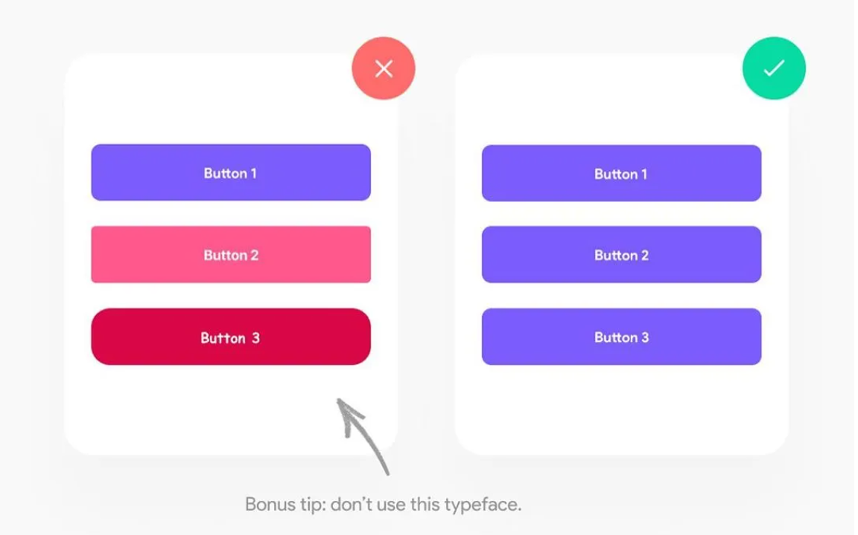
3. Simplify
- Avoid overwhelming the user with too much information and elements
- Keep the interface clean and simple, focusing on core functions and content
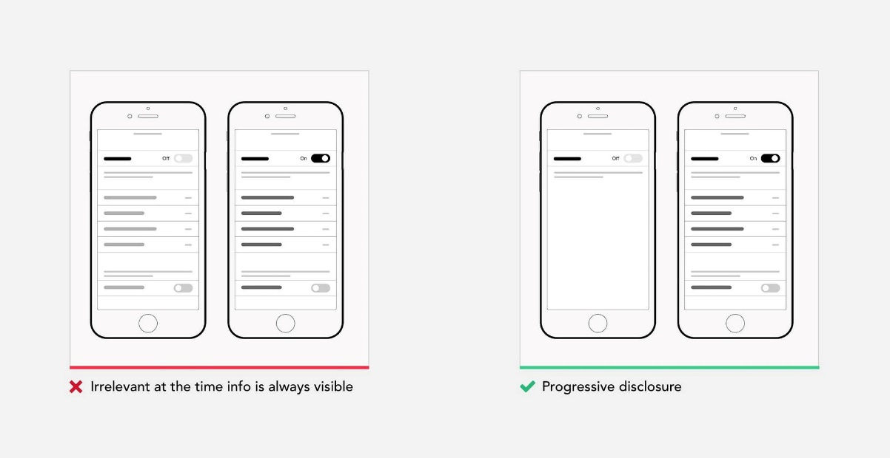
4. Visual Hierarchy
- Use visual hierarchy to guide users' attention to the most important elements
- Utilize sizes, colors, and positioning to highlight key elements and content
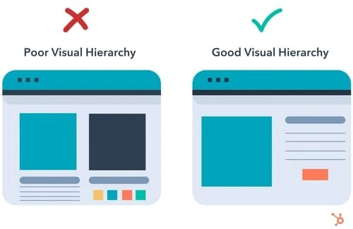

5. Readability
- Use easy-to-read fonts and sufficiently large text size
- Ensure adequate contrast between text and background
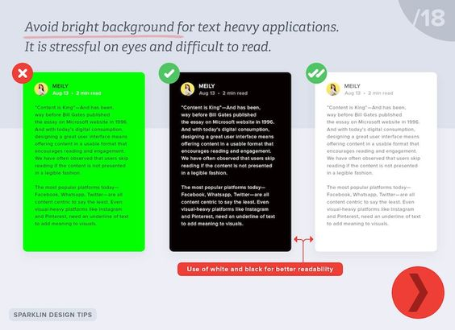

6. Easy to Find Call-to-Action Buttons
- Provide clearly labeled and easily accessible action buttons (like "Buy Now," "Sign Up," "Learn More")
- Use contrasting colors to make them visible

7. Interactive Elements
- Provide feedback when interacting with interactive elements like buttons, links, and forms
- This can include color changes, animations, or other visual indicators

8. Whitespace
- Use sufficient white space to make content easier to perceive and to improve the overall aesthetic of the site
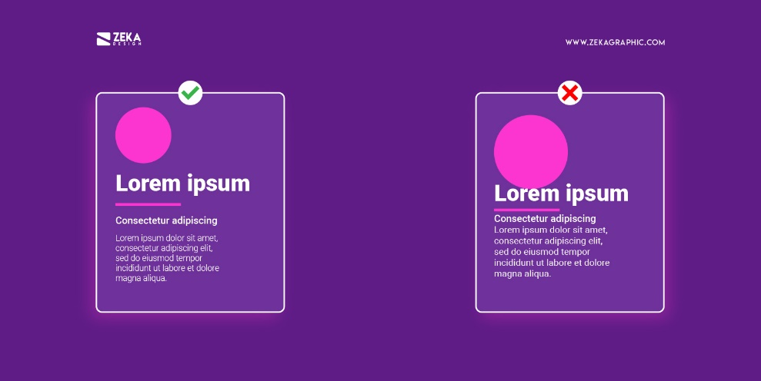
9. Intuitive Icons
- Use easily recognizable icons that clearly indicate their function
- Avoid complex icons that may confuse users
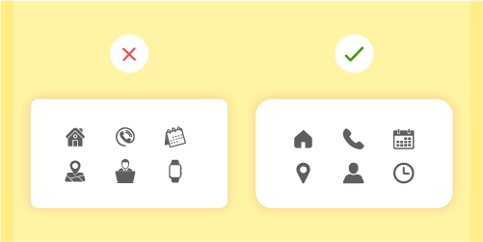

10. Use of Visuals
- Utilize high-quality images and graphics that complement the content and enhance the visual appeal of the site
- Avoid excessive use of stock images

11. Color Selection
- Create a limited color palette that includes primary, secondary, and accent colors
- Ensure sufficient contrast
- Use accent colors to highlight important elements and neutral colors (like white, black, gray) for background and other secondary elements

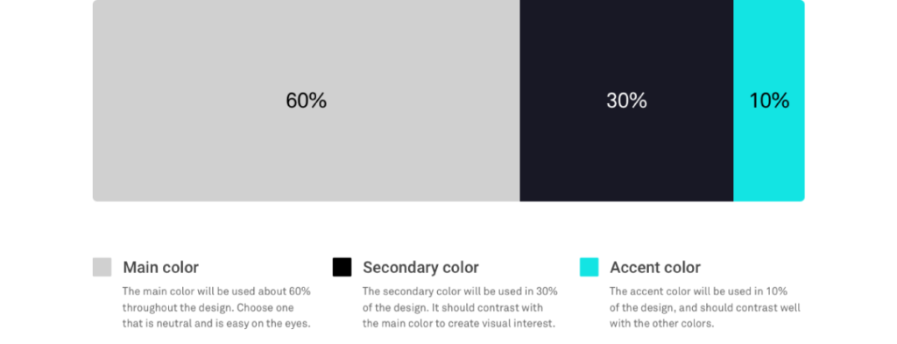
12. Bonus Resources
- https://digitalsynopsis.com/design/ui-ux-design-tips/
- https://www.paulinewiles.com/articles/12-done-for-you-website-color-schemes
- https://wpmudev.com/blog/hack-your-way-to-great-design-basic-design-principles-for-wordpress-developers/
- https://yellowchalkuiux.medium.com/8-golden-rules-of-interface-design-dff2133c4a66

